# Sprint 4 Plan: SlugManager

Team: Asher Etherington, Kenneth Losier, Mia Santos, Nathan Le, Poppy Garner, Gino Zarich

Sprint Completion date: 06/03/24

Revision Number and Date:

## Goals: Add styling and formatting to each page to ensure a user friendly interface and visually appealing website. Fine tune the functionality for all buttons, projects, tasks, searching, etc.

## Task Listing:

User Story 5 (US.A):

As a project admin, I need to have a dashboard that allows me to overview the progress on all my projects, as well as be able to track the progress of individual team members. This dashboard should be different from the team member dashboard, and be simple to use and understand. [Story Points: 5]

* Task 1
* Task 2

User Story 4 (US.A):

As a project ‘administrator’ I want to be able to assign tasks to other team members. [Story Points: 5]

* Task 6

Tasks:

These tasks include any other styling that needs to happen

* Task 1: Fix the sizing of the boxes and other page components for when each screen is minimized it will adjust accordingly. Remove the “About” button from the Landing Page. (1 hour)
* Task 2: Have the project page refresh itself when a new project is created, as the task page does. (1 hour)
* Task 3: Add an edit button for the description of tasks and projects in case there are changes needed. Also add a delete button for the tasks. (3 hours)
* Task 4: The website should display error messages whenever the user fails to create a project, task, or when adding users to a project or assigning to task.(2 hours)
* Task 5: Look for a free way to deploy Slug Manager so that our website can be viewed from anywhere (3 hours)
* Task 6: Add a button to the task creation where the admin can assign tasks to specific individuals. The task should clearly display who is supposed to work on the task, but others can still contribute. (4 hours)

Total for user story: 14 hours

## Team Roles:

Asher Etherington: Developer

Kenny Losier: Developer

Mia Santos: Developer

Nathan Le: Scrum Master

Poppy Garner: Developer

Gino Zarich: Project Owner

## Initial Task Assignment:

Gino Zarich: Task 3

Asher Etherington: Task 5

Kenny Losier: Task 1 & 2

Mia Santos: Task 4

Nathan Le: Task 6

Poppy Garner: Task 6

## Initial Burnup Chart:

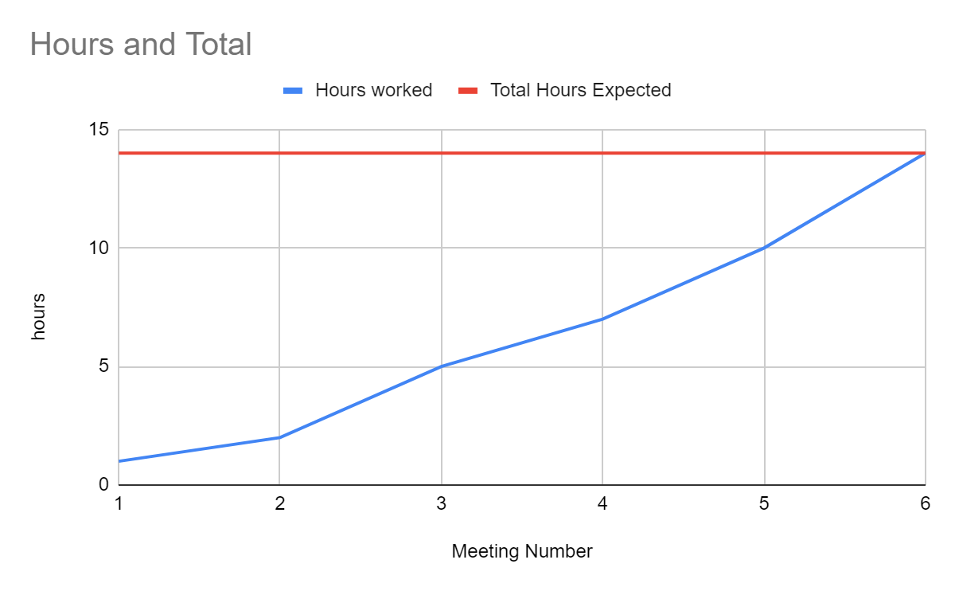

## Scrum Board:

| **User Story** | **To Do** | **In Progress** | **Done** |
| --- | --- | --- | --- |
| **US.A** | **Task 1** |  |  |
|  | **Task 2** |  |  |
|  | **Task 3** |  |  |
|  |  |  |  |
| **US.B** | **Task 4** |  |  |
|  | **Task 5** |  |  |
|  | **Task 6** |  |  |

## Definition of Done:

## Scrum Times:

Monday: Team Meeting 9:15-10:15 AM

Tuesday: Meeting with TA 2:15-3:15 PM

Wednesday: Team Meeting 9:15-10:15 AM

Friday: Team Meeting 9:15 - 10:15 AM